

Entel DX485 User “Crib Sheet”

The Entel DX485 is an advanced digital walkie-talkie with smart features. One of the most useful of these features is the ability to communicate individually with one other radio user in a group, and also with different groups of users.

Turn the radio(s) on using the rotary on / off / volume knob on top of the radio and set the volume to the desired level.

They will display the Entel logo screen for a few seconds, then the display will show the channel number.

In order for any radios to communicate with each other, they MUST all be set to the same channel.

There are currently 14 channels set up on the radios.

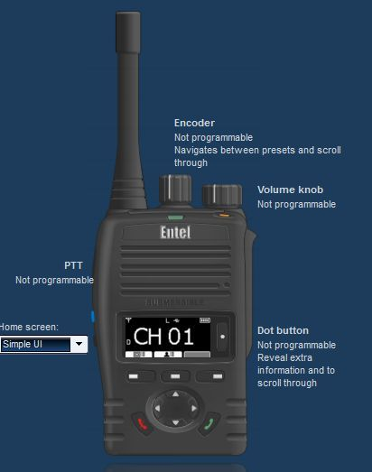
To choose a channel, rotate the channel selection knob on the top of the radio, and watch the display screen show the current channel number.

The way that your radios are set up, several of the buttons are not in use.

For example, neither of the red and green “telephone” buttons are in use.

Power Level Selection

You can select high or low power by pressing and holding the blue button on the side of the radio for a couple of seconds until the little letter on the display changes from “H” for “High” to “L” for Low power.

Using Low power reduces the radio’s transmission range, but makes the battery charge last longer. Generally, use High power.

Who Am I?

To display the user name of your own radio, press the button to the right of the display screen until the display shows “My ID: <user name>

Group Calling (Call Everyone)

Press the middle key under the screen with the image of a person’s head and a list next to it on the screen.

You will see a list of choices. The first choice will be “Group 001” which is “everyone”.

Select this using the up and down arrow keys, then the right-hand button under the screen that has a tick next to it on the display to choose the option you want.

Now, when you press the big Push-To-Talk button on the left side of the radio, you will transmit to everyone in your group.

Individual Selective Calling

Press the middle key as described for “Group Calling” above. Underneath the “Group 001” entry will be a list of users in number order.

Select the user using the up and down arrow keys, then the right hand button under the screen that has a tick next to it on the display to choose the option you want.

Now, when you press the big Push-To-Talk button on the left side of the radio, you will transmit only to the chosen user.

If you set your radio to send to an individual, you need to remember to set it back to “Group” if you generally would like to send a message to all the users in your group.

